Help reforest the Amazon for £1
TReeS is supporting the reforestation of an ex-ranch (30 hectares) in Madre de Dios, south-east Peru, by APRONIA – a local organisation for homeless children, some of whom assist with the project. Madre de Dios is known as the ‘biological capital’ of the world and holds world records for birds (600+ species) and butterflies (1200+ species).
TReeS has already supported the reforestation of 4 hectares of abandoned grassland with a mix of cacao, brazil-nut, banana, citrus and timber species. Over time the fruit trees will be replaced with other timber species.
The project prepares the land, nurtures the seedlings, plants them out and maintains the trees for £1 each. The plan is to plant another 2 hectares in 2019-20 – each hectare requires 2,000 seedlings.
The trees planted 5 years ago are now 3-5 metres tall, the cacao trees are covered in pods and the citrus trees are expected to produce 40 tonnes of fruit in 2019. The fruit is consumed in a local lodge¹ linked to the project and in the ‘Gustitos de la cura’ juice and ice-cream parlour in the nearby town of Puerto Maldonado.
Initial research suggests that a fully grown tropical tree can absorb up to 25kgs of carbon dioxide per year². This means that a £5 donation will offset the emissions of most international individual return flights.
If you would like TReeS to support the planting of more trees to offset the carbon emissions this year resulting from your daily activities, flights or car journeys, business operations, trips or holidays, donations can be made to ‘TReeS’ as follows –
*By ‘cheque’ made out to ‘TReeS’ and sent to: P.O.Box 33153,
London NW3 4DR
*By ‘bank transfer’ to our bank account: Lloyds Bank Plc
Account number: 00574637 Sort code: 30 99 83

TReeS annual membership: £15.00 (if you would also like to join TReeS)

The aim is to plant 2 hectares in 2019: a hectare requires 2,000 seedlings.
Tambopata Reserve Society (TReeS) - Registered charity 298054
¹https://www.estanciabellohorizonte.com/
²http://www.communitycarbontrees.org/climate-change-solutions

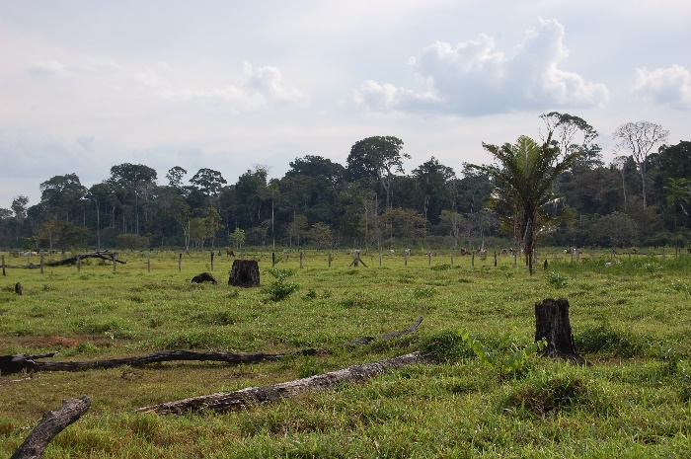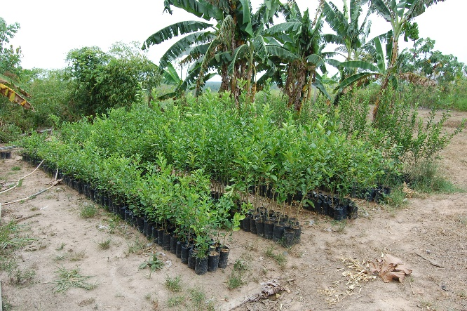

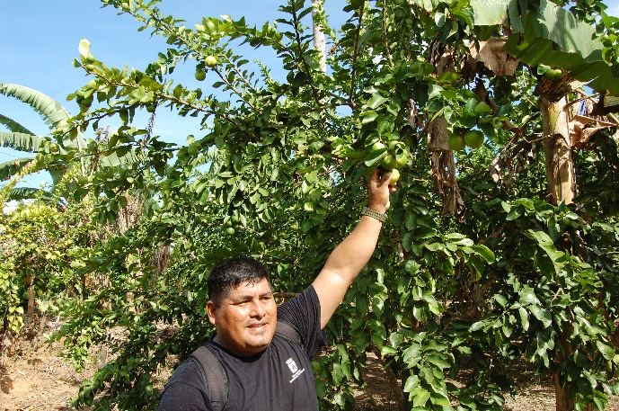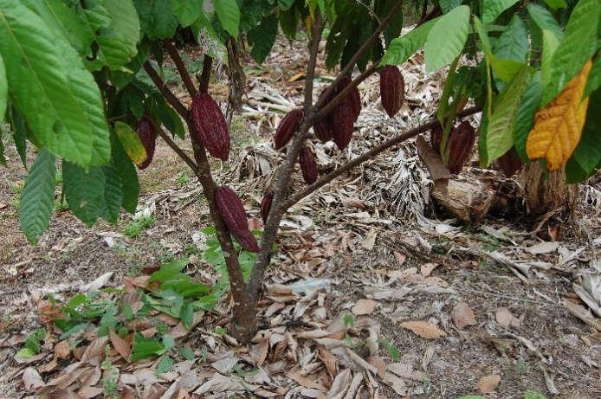

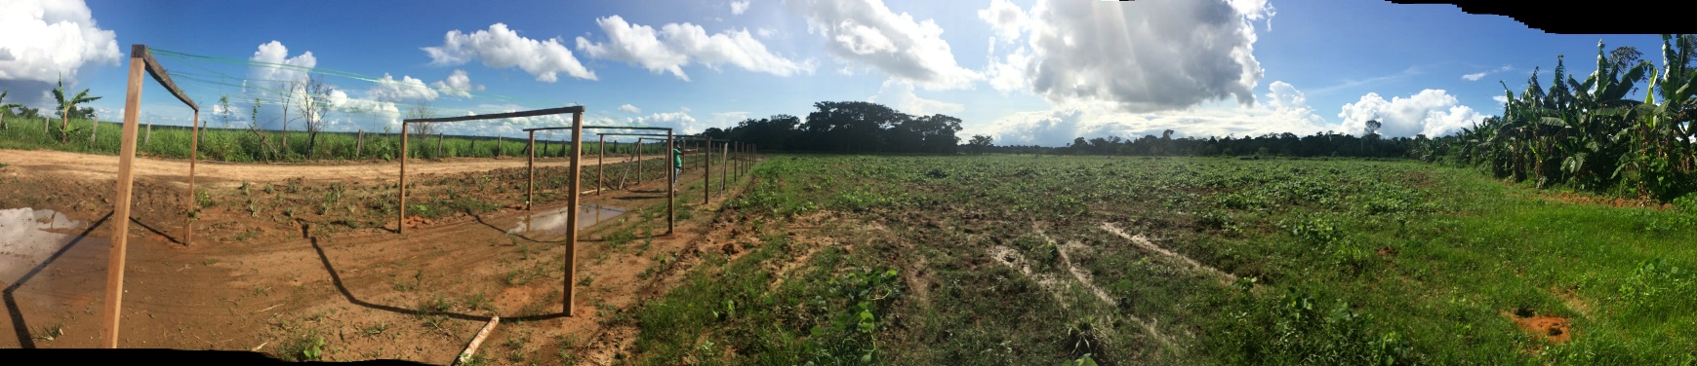
Top Left - The ranch in its final days with cattle (in the far distance). The area in the foreground has been reforested and is now where the two middle photos were taken.
Top Right - Citrus seedlings ready for planting out.
Middle Left - Forestry engineer Amilcar Muñiz reaches for a bunch of ready to pick limes on a 4 year old tree.
Middle Right - Cacao pods ready for harvesting.
Bottom - the next area of abandoned ranch land ready for planting, with frames for maracuya (passion fruit) vines already installed along the access track.

